Hakobyan Howhannes

Batch Size and Obstacle Avoidance:

A PPO-Based Study of Autonomous Vehicles Using Unreal Engine Learning Agents

Supervisor: Boury Fries

Coach: Geeroms Kasper

Graduation Work 2024-2025

Digital Arts and Entertainment

Howest.be



Contents

2. Abstract & Key words 3

3. Preface 4

4. List of Figures 5

5. Introduction 6

6. Literature Study / Theoretical Framework 7

6.1 Introduction 7

6.2 Machine Learning 7

6.3 Reinforcement learning (RL) 8

6.4 Proximal Policy Optimization 10

6.5 Policy batch size 10

6.6 Autonomous driving 11

6.7 Unreal Engine Learning Agents 11

6.7.1 Interactor 12

6.7.2 Trainer 12

7. Research 13

7.1 Introduction 13

7.2 Experimental Setup 13

7.3 Training 14

7.3.1 Learning To Drive 15

7.3.2 Obstacle Avoidance 18

7.4 Testing 22

7.4.1 Environment 22

7.4.2 Data Collection 22

7.5 Results 22

8. Discussion 23

9. Conclusion 24

10. Future work 25

11. Critical Reflection 26

12. References 27

13. Acknowledgements 28

14. Appendices 29

14.1 Appendix List 29

14.2 Appendix A: Learning Agents Framework 30

14.3 Appendix B: Learning To Drive 33

14.4 Appendix C: Obstacle Avoidance – Setup 39

14.5 Appendix D: Obstacle Avoidance – Approach 1 41

14.6 Appendix E: Obstacle Avoidance – Approach 2 44

14.7 Appendix F: Obstacle Avoidance – Approach 3 46

14.8 Appendix G: Obstacle Avoidance – Approach 4 49

# Abstract & Key words

**An abstract explains the outline of the paper concisely (the methods, results, etc.). Maximum length of 250 words, preferably both in English and Dutch.**

Lorem ipsum dolor sit amet, consectetur adipiscing elit. Vestibulum ac quam nec arcu semper dignissim. Nulla quam magna, varius sit amet pharetra et, dictum quis elit. Pellentesque habitant morbi tristique senectus et netus et malesuada fames ac turpis egestas. Proin ullamcorper, ipsum sit amet scelerisque rhoncus, leo quam rhoncus elit, sit amet ullamcorper tellus nisi eget sapien. Suspendisse potenti. Ut non justo viverra, tempus felis vitae, elementum mi. Morbi at dui sed lacus fringilla condimentum. Duis non odio ac arcu volutpat vehicula eu et turpis. Praesent vitae magna ante. Nulla in orci lacus. Donec quis vestibulum mi. Sed ipsum sapien, pretium maximus purus sed, bibendum consequat lectus. Aliquam porttitor dolor eu gravida vulputate. Vestibulum ut urna eget massa tincidunt ultricies. Morbi hendrerit sapien at diam tincidunt semper. Aliquam ut quam dictum quam maximus tempor sed at felis.

# Preface

***A preface is a statement of the author's reasons for undertaking the work and may include personal comments that are not directly relevant to other sections of the thesis or dissertation.* No word count limit.**

Lorem ipsum dolor sit amet, consectetur adipiscing elit. Vestibulum ac quam nec arcu semper dignissim. Nulla quam magna, varius sit amet pharetra et, dictum quis elit. Pellentesque habitant morbi tristique senectus et netus et malesuada fames ac turpis egestas. Proin ullamcorper, ipsum sit amet scelerisque rhoncus, leo quam rhoncus elit, sit amet ullamcorper tellus nisi eget sapien. Suspendisse potenti. Ut non justo viverra, tempus felis vitae, elementum mi. Morbi at dui sed lacus fringilla condimentum. Duis non odio ac arcu volutpat vehicula eu et turpis. Praesent vitae magna ante. Nulla in orci lacus. Donec quis vestibulum mi. Sed ipsum sapien, pretium maximus purus sed, bibendum consequat lectus. Aliquam porttitor dolor eu gravida vulputate. Vestibulum ut urna eget massa tincidunt ultricies. Morbi hendrerit sapien at diam tincidunt semper. Aliquam ut quam dictum quam maximus tempor sed at felis.

# List of Figures

**The list of figures lists the figures in the order in which they appear throughout the thesis. They may be numbered sequentially, or be subdivided following the chapters in which they appear.**

*Figure 1: Different Types of ML (Experfy, n.d.)* 7

Figure 2: Reinforcement Learning framework (Scribbr, n.d.) 9

Figure 3: Reinforcement Learning taxonomy (OpenAI, 2018) 10

Figure 4: Track layout used for training AVs 13

Figure 5: Vehicle used for training and testing 14

Figure 6: World observation of the agent 15

Figure 7: Accessing Agent in GatherAgentObservation in Learning Agents 16

Figure 8: SpecifyAgentAction function implementation for autonomous driving 16

Figure 9: Perform Steering logic 17

Figure 10: Autonomous driving agent after 2 hours of training 17

Figure 11: Racing track populated with static obstacles 18

Figure 12: Agent with a singular sphere cast detecting obstacle 19

Figure 13: Agent with a singular sphere cast and enhanced radius 19

Figure 14: Agent with 5 lines representing the vision 20

Figure 15: Penalty for getting too close to an obstacle 21

Figure 16: Multiple agents driving around the track 22

# Introduction

**In the introduction, you write the background of your topic and discuss the observation that spurred you on to do this research project. Explain the purpose of the paper and present your research question(s) and the hypothesis at the end of this section. This section is typically a couple of pages long.**

Lorem ipsum dolor sit amet, consectetur adipiscing elit. Vestibulum ac quam nec arcu semper dignissim. Nulla quam magna, varius sit amet pharetra et, dictum quis elit. Pellentesque habitant morbi tristique senectus et netus et malesuada fames ac turpis egestas.

Proin ullamcorper, ipsum sit amet scelerisque rhoncus, leo quam rhoncus elit, sit amet ullamcorper tellus nisi eget sapien. Suspendisse potenti. Ut non justo viverra, tempus felis vitae, elementum mi. Morbi at dui sed lacus fringilla condimentum. Duis non odio ac arcu volutpat vehicula eu et turpis.

Praesent vitae magna ante. Nulla in orci lacus. Donec quis vestibulum mi. Sed ipsum sapien, pretium maximus purus sed, bibendum consequat lectus. Aliquam porttitor dolor eu gravida vulputate. Vestibulum ut urna eget massa tincidunt ultricies. Morbi hendrerit sapien at diam tincidunt semper. Aliquam ut quam dictum quam maximus tempor sed at felis.

# Literature Study / Theoretical Framework

## Introduction

This section provides an overview of existing research and theoretical concepts relevant to the impact of experience replay batch size and obstacle avoidance AVs trained using PPO. It establishes the background needed to contextualize this study.

## Machine Learning

Machine learning (ML) enables computers to perform actions without explicit programming (Bi et al., 2019). When complex behaviors are required, it is often a burdensome task to explicitly program those behaviors. ML provides a more efficient approach to developing advanced and human-like behaviors.(Janiesch et al., 2021)

There are several types of ML, such as Supervised ML, Unsupervised ML, Reinforcement Learning (RL) and Semi-Supervised ML.(Jain, 2023). This paper will only explore RL, as it is a common choice when training AVs (Kiran et al., 2021)

*Figure 1: Different Types of ML (Experfy, n.d.)*

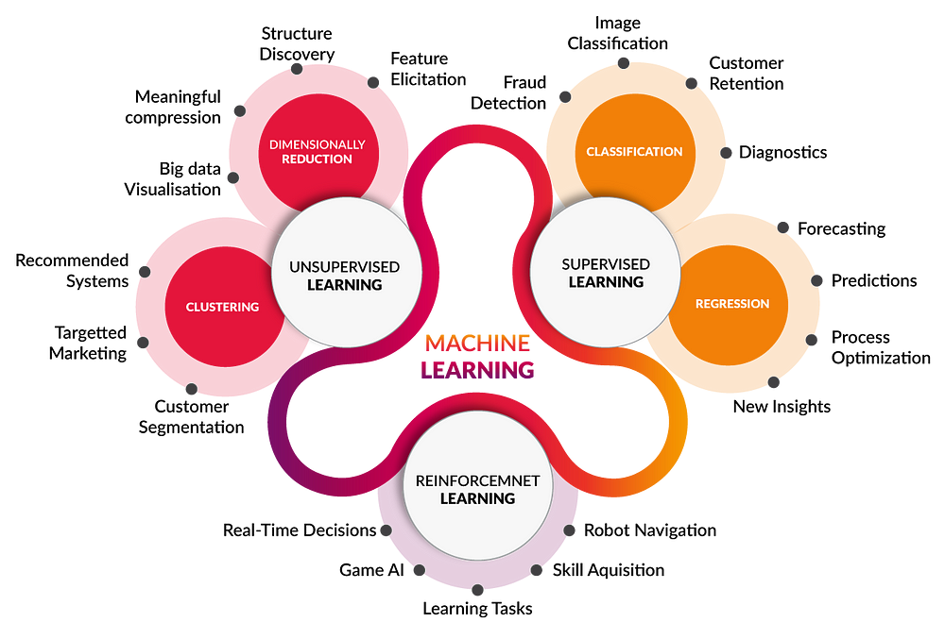

## Reinforcement learning (RL)

Reinforcement Learning (RL) is an area of machine learning where the agent develops its behavior based on actions, observations and rewards. A common way of achieving this is by trial-and-error. The agent is forced to interact with the environment, and based on the actions it performs, a positive reward or a negative reward, also referred to as a penalty, will be given. The goal is to maximize the total reward, while balancing exploration (trying new actions) and exploitation (choosing the best-known and most-rewarding action).(Crespo & Wichert, 2020)

The environment in which the agent is being trained can be extensive, with numerous observable elements and a wide range of possible actions. It is the responsibility of the developer to specify what an agent observes, the actions it can take, and the rewards for specific behaviors.

Here are some key concepts in RL:

* *The State* represents the current condition of the environment. It encompasses all the information about the world. (OpenAI, 2018)
* *Observations* represent the information the agent receives from the environment. Using observations the current state of the environment is captured, and this information is fed into the agent’s knowledge base. For example, in a traffic situation, observations might include the positions, directions and speeds of nearby vehicles, the weather conditions, the status of traffic lights and the agent’s own velocity and direction. These observations heavily influence the agent’s decision-making (Arabaci, 2023).
* *Actions* represent the interactions with the environment. The collection of all valid actions in an environment is called the **action space** (OpenAI, 2018). One of the main challenges is finding the perfect balance between actions that yield high results, and actions that have not been executed yet as part of the discovery process (Kiran et al., 2021). Revisiting the earlier traffic example, possible actions could include throttle, braking, and steering.
* *Policies*are the link between the current state of the environment the agent finds itself in, and the action it should take in that situation. It can be a function, a matrix, or an array of probabilities of each action being chosen (Crespo & Wichert, 2020). The words “agent” and “policy” are often used interchangeably because the policy is essentially the agent’s brain (OpenAI, 2018).
* *Rewards* play a significant role in the agent’s development. In each state, the agent receives a reward from the environment based on the action it took. If that action leads to desired outcomes, the reward is positive, otherwise the reward is negative. The agent strives to maximize the cumulative rewards received over the span of its training, leading to desired behavior (Kiran et al., 2021). In the previously mentioned traffic scenario, actions such as driving through a red light, or crashing into other cars could yield negative rewards, while driving under the speed limit, and avoiding collisions could lead to positive rewards.

As previously mentioned, reward shaping is crucial in RL. A well-designed reward function will lead to a more desirable outcome, while a bad design might lead to suboptimal behavior. To shape the reward function properly, one must define the goal of the agent, and the key behaviors the agent must learn. Afterwards, all the actions or states that either reward or penalize the agent must be identified.

* **Rewards** are given to encourage the agent to take certain actions in specific scenarios
* **Penalties** are given to discourage the agent from taking incorrect actions.

It is also important to note that having a disproportionately high or low rewards or penalties can lead the agent to over-focus on certain actions, not prioritizing reaching the goal (GeeksforGeeks, 2024).

Figure 2: Reinforcement Learning framework (Scribbr, n.d.)

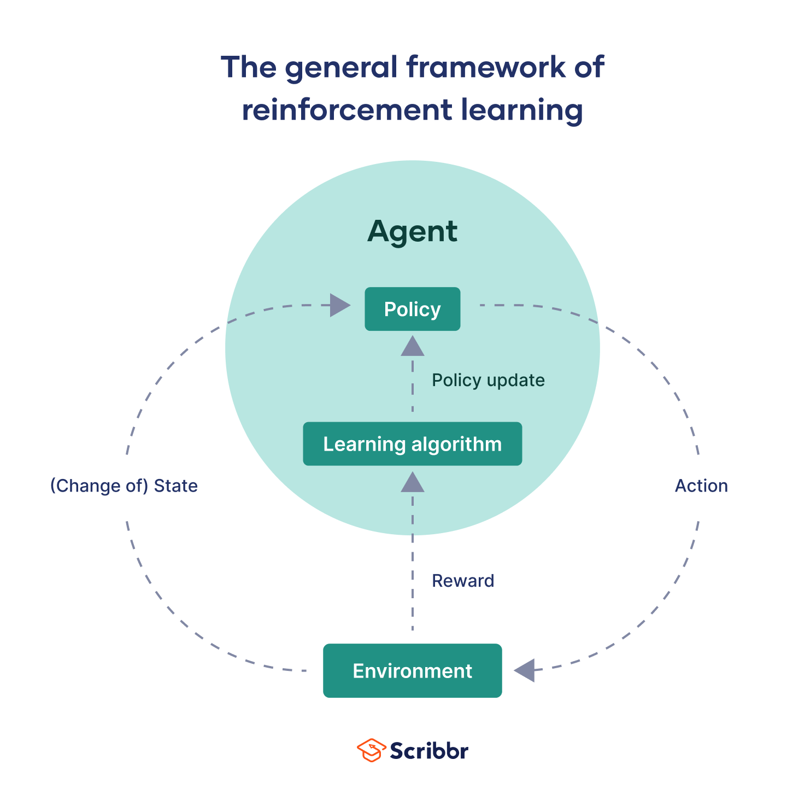

## Proximal Policy Optimization

Proximal Policy Optimization (PPO) is one of many RL algorithms, developed by John Schulman in 2017. It is widely used by American artificial intelligence company OpenAI and is considered a state-of-the-art RL algorithm by many experts (Kumar, 2024; OpenAI, 2017).

PPO is part of Policy Optimization methods, where the agent learns the **policy function** that maps state to action directly (SmartLab, 2019). To determine how well an agent is performing, and to decide which action the agent should take for each state, the policy function must be evaluated. When the agent is in the initial stages of learning and doesn’t know which actions lead to the best results, it does so by calculating the **policy gradients.** The output of the gradients helps the agent determine which actions are most likely to lead to higher rewards (Kumar, 2024).

Figure 3: Reinforcement Learning taxonomy (OpenAI, 2018)

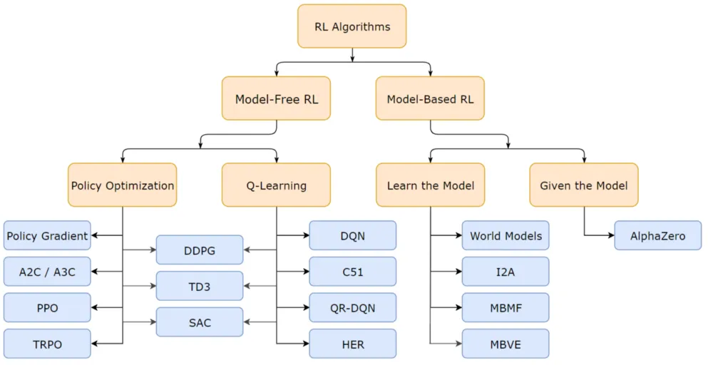

## Policy batch size

**Policy batch size** refers to the number of samples processed together during training. In the context of RL, it specifically denotes the number of experiences grouped for training updates. Each experience typically comprises:

* The **state** of the agent
* The **action** the agent takes in that state
* The **reward** of the set action
* The **next state** of the agent
* Weather the episode terminates (Bacancy, 2024).

Before calculating a gradient update, a batch is processed. The size of this batch is controlled by the developer. For performance reasons it is advisable to keep the batch size to a power of two (jcm69, 2017).

Batch size is an important hyperparameter to tune. It is known that too large of a batch size will lead to poor generalization, and a smaller batch size is not guaranteed to deliver the desired outcome. It is also known that a smaller batch size leads to faster training, while a relatively big batch size leads to “guaranteed” results. It is important to mention that making general statements about the effects of hyperparameters is very difficult, as behaviour often varies from dataset to dataset (Shen, 2018). Therefore, it is up to the developer to determine what is referred to as the “optimal batch size” for the training process.

## Autonomous driving

Autonomous driving (AD) refers to the process of navigating a vehicle with partial or no human intervention. AVs utilize technology to avoid road hazards and adapt to traffic conditions (CFSS, n.d.). It has been a popular research topic since the end of the last century, because it promises many benefits such as safety and time savings (Wen et al., 2020).

Thanks to the rapid development of hardware, simulations enable us to test various AD algorithms with significantly reduced labour cost and time. More importantly, it takes the human error of breaking expensive equipment out of the equation (Wen et al., 2020).

Decision-making systems for real-life AV are often complex, including various sensors to fetch data from the environment, mapping algorithms for localization, understanding human drivers and predicting their behaviour, and engaging in kinematic manoeuvres (Barla, 2022). However, for the purposes of this paper, it is sufficient to focus solely on environment sensing.

The most common sensors used in real-life AV trainings include cameras, LiDAR, and RADAR (Barla, 2022). However, for the scope of this paper, ray tracing will be utilized for environment sensing and obstacle detection, as it is a more practical choice for this study.

## Unreal Engine Learning Agents

Learning Agents is an Unreal Engine ML plugin for AI bots. It currently supports reinforcement & imitation learning to create game-playing agents, physics-based animations, automated QA bots and more. It is not a general-purpose ML framework, so generative and conversational AI are not supported (Epic, 2024).

Learning Agents is intended for developers with different ML knowledge levels. Beginners can take advantage of the available plugins in Blueprints, while more advanced users can utilize the C++ API for greater control and flexibility (Epic, 2024; HuggingFace, n.d.).

The plugin comes with a built-in PyTorch PPO algorithm for RL. Functionality for defining observations, actions and rewards are provided (Epic, 2024).

To enhance the readability of this paper, the Blueprint interface will be used to implement functionalities and demonstrate key concepts.

LA comes with a straightforward implementation of RL. The plugin is built around the LA Manager, around which the rest of LA is built. It stores references to the various agents, and is used to specify learning logic, such as batch size, number of iterations etc. Listeners such as the *Interactor* and the *Trainer* are used to extend existing functionality of the manager (see Appendix A: Learning Agents Framework for Blueprint examples) (Epic, 2024).

### Interactor

The interactor is utilized to specify the observations and actions of the agent. All agents share a common schema of observation and actions for a given manager. There are four functions that need to be overridden to complete the interactor (Epic, 2024).

**SpecifyAgentObservation** is used to specify all the observations. The manager calls this function once during setup. There are numerous pre-defined observations that come with the plugin (Epic, 2024).

After the observations are specified, they must be gathered. This step is carried out through **GatherAgentObservation** function. For each observation specified, there is a corresponding *gather*node that must be provided.

**SpecifyAgentAction** and **PerformAgentAction** are used for specifying and performing actions respectively. The functions are part of the Interactor.

### Trainer

The trainer, as the name suggests, is responsible for training the agents to perform the correct actions, based on the observations they see. Two functions need to be implemented: rewards and completions (Epic, 2024).

**GatherAgentReward** is used to reward the actor for desired behaviour and penalize it for incorrect actions. As always, there are multiple pre-defined nodes that come as part of the plugin.

When the agent gets into a bad state where no meaningful learning can occur, for example it has driven off the track, we can end the training early. This speeds up training and can be specified in **GatherAgentCompletion** (Epic, 2024)**.**

There are 2 categories: terminations and truncations. Terminations are used in situations where it is assumed that the agent will receive a reward of zero for all further steps. Truncations are used when an early end of the eposide is expected, but where the agent would have continued to receive more rewards (Epic, 2024).

# Research

## Introduction

The purpose of this research is to train autonomous vehicles (AVs) capable of navigating a road, staying within bounds, and avoiding static obstacles randomly placed along the path. Five AVs will be trained using identical hyperparameters, with the only variable being the policy batch size. After training, the AVs will be tested on three distinct track types: linear, circular, and zigzag. During these test episodes, data on obstacle avoidance performance will be collected and analyzed. The findings will be compared to draw meaningful conclusions. The detailed methodology is explained in the following sections.

## Experimental Setup

All the experiments in this paper are conducted in Unreal Engine (UE) 5.4. The engine offers a built-in vehicle template and a racing track map, which significantly reduces development time. Another key reason for choosing UE is to explore and test the Learning Agents (LA) plugin, as it is relatively new and underrepresented in academic research.

The Landscape tool in UE enables the creation of diverse track layouts with ease, saving significant time when designing multiple track configurations. Additionally, UE provides powerful debugging tools that are particularly beneficial for RL, where debugging can often be a challenging process.

This project utilizes LA 5.4. Despite being an experimental plugin, it perfectly serves the purposes of this research.

The default track layout, as shown in Figure 4, is used to carry out the training iterations. This layout is chosen as it represents a balanced middle ground, allowing for evaluation of the agent's behavior in both simpler and more complex maps after training. The length of the track is 1017m.

Figure 4: Track layout used for training AVs

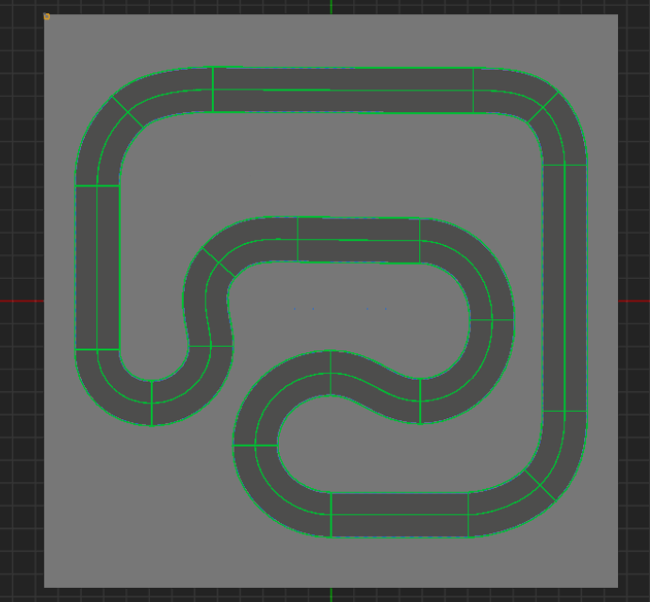

UE SportsCar_Pawn, that comes with the vehicle template, is utilized for both training and testing. No changes have been made to the vehicle set-up.

Figure 5: Vehicle used for training and testing

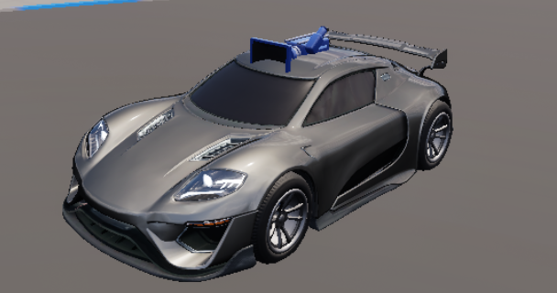

Five agents are trained over 5,000 iterations, each with a distinct batch size: 16, 32, 64, 128, and 256. To accelerate the training process, multiple instances of the same agent are trained simultaneously. The training is conducted in five phases, with each phase focusing on one batch size and involving 16 agents training concurrently. Upon completion of each phase, the training is halted, and the training data is saved into four Unreal Data Assets: Critic, Decoder, Encoder and Policy. TO BE CONTINUED

## Training

The training of a single agent is divided into two stages. In the first stage, the agent's sole focus is to complete a full lap while staying within the track boundaries. Once this is successfully achieved and the implementation is verified, static obstacles are introduced into the environment. In the second stage, the agent's behavior is updated to account for these obstacles, and the new goal becomes navigating the track while avoiding collisions with obstacles. Multiple approaches are explored until the agents can navigate the track while avoiding collisions. During this process, a policy batch size of 512 is used.

### Learning To Drive

This section is fully implemented based on [*Learning to Drive (5.4)*](https://dev.epicgames.com/community/learning/courses/kRm/unreal-engine-learning-agents-5-4/owjW/unreal-engine-learning-to-drive-5-4#learningagentstrainer) and [*Improving Observations & Debugging (5.4)*](https://dev.epicgames.com/community/learning/courses/kRm/unreal-engine-learning-agents-5-4/dpqe/unreal-engine-improving-observations-debugging-5-4)tutorials provided by Epic Games (Epic, 2024).

As discussed in *Unreal Engine Learning Agents* chapter, the Interactor and the Trainer must be implemented.

#### Specifying Observations

To make the agent follow the road and stay in bounds, there are multiple important observations to be made. The agent must be aware of the nearest point to the spline that follows the road, and it must know the direction of the spline at that point. To enhance the “vision” of the agent, the above-mentioned observations are done at different distances, allowing the agent to “look ahead” and be aware of the environmental changes that will occur. A *static array observation* is utilized, consisting of 7 *struct observations*. Each item in the struct holds a pair of *Location* and *Direction* observations.

Figure 6: World observation of the agent

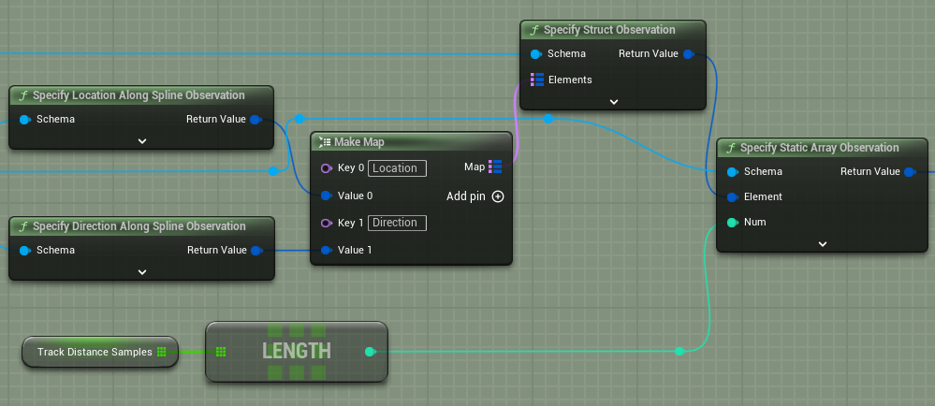

Another crucial observation is the agent’s velocity, which will be used to reward the agent for driving as fast as possible (see Appendix B: Learning To Drive for Blueprint implementation).

#### Gathering Observations

For this step, the agent is necessary to gather information such as its own velocity. The agent can be accessed as follows:

Figure 7: Accessing Agent in GatherAgentObservation in Learning Agents

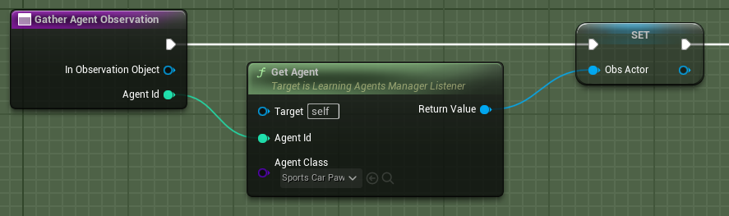

The data is gathered following the same structure specified in *SpecifyAgentObservation*. Each node used during the specification has a corresponding node for gathering the set information. To gather observations for the vision of the agent, the track spline is utilized. Using *GetDistanceAlongSplineAtLocation*node, the sample distance is calculated for the following lookahead observations: 5m, 10m, 15m, 20m, 25m, and 30m. This data is used to gather direction and location observations along the track spline.

Gathering velocity observation data is straightforward. It is accessed directly using the agent (see Appendix B: Learning To Drive for Blueprint Implementation).

#### Specifying Actions

There are two actions necessary for the agent to navigate the world: throttle/brake and steering. A struct action is specified, consisting of two float actions (see Figure 8). Float actions are used because the *Vehicle Movement Component*in Unreal Engine expects a float value for steering, throttle and brake inputs (see Appendix B: Learning To Drive for Blueprint implementation).

Figure 8: SpecifyAgentAction function implementation for autonomous driving

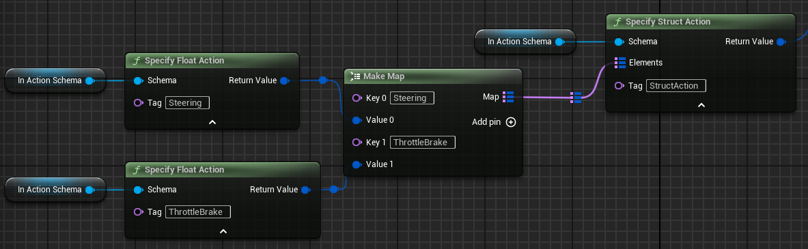

#### Performing Actions

To finalize the Interactor, action performing logic is provided. The float value of *Steering Action* is fed into *SetSteeringInput* function of the *Vehicle Movement Component*, enabling the agent to be able to steer on the road. The value is between -1 and 1 (see Figure 9).

Throttle/brake logic is more complex. If the float action yields a positive number, that number is fed into *SetThrottleInput* function, and *SetBrakeInput* takes 0. If the resulting number is negative, then the positive of that number is used as an argument in *SetBrakeInput*, while *SetThrottleInput* takes 0 (see Appendix B: Learning To Drive for Blueprint implementation).

Figure 9: Perform Steering logic

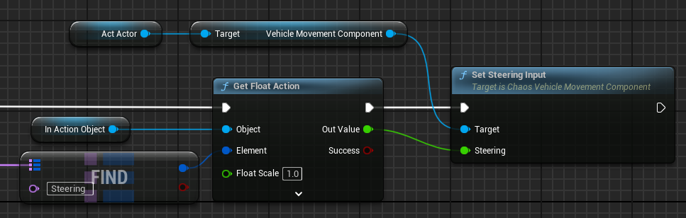

#### Gathering Rewards

The agent is given positive rewards for driving as fast as possible along the spline. This is obviously not enough, because the agent still leaves the track bounds considering it is not penalized for doing so. A negative reward is introduced if the distance between the agent and the spline is greater than the distance between the spline and the road “walls” (see Appendix B: Learning To Drive for Blueprint implementation).

#### Result

Using the above-mentioned configuration, the agents learn to drive around the training track (see Figure 4) without leaving its bounds. After training 16 agents simultaneously, the driving skills are significantly improved if the simulation is running for at least 30 minutes. After two hours of training, the agent can navigate the track infinitely without leaving its bounds.

Figure 10: Autonomous driving agent after 2 hours of training

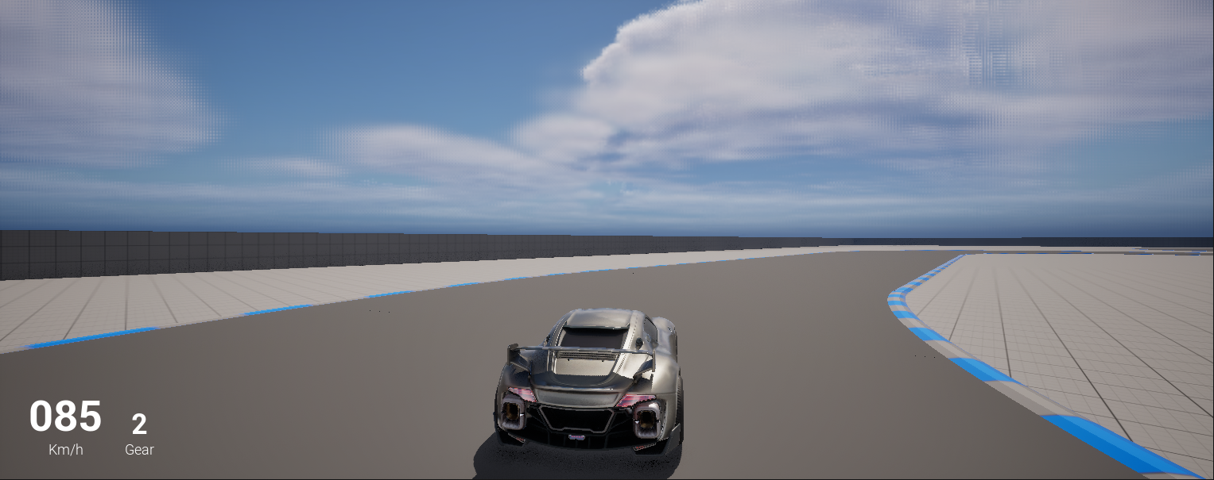

### Obstacle Avoidance

To introduce obstacle avoidance into the training, static obstacles are randomly distributed across the track. Every time the simulation is run, a change in obstacle layout is guaranteed (See Figure 11).

Figure 11: Racing track populated with static obstacles

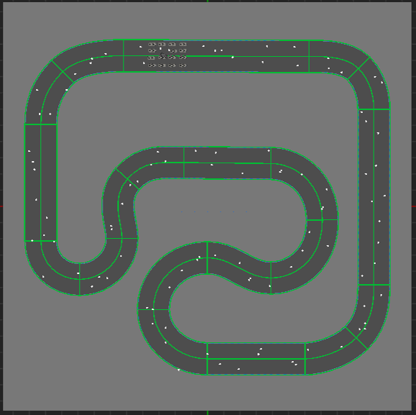

The obstacle is an *Actor Blueprint*, containing a cube mesh and a box collision. Those actors are created using *SpawnActor* node and are guaranteed to be within the bounds of the track (see Appendix C: Obstacle Avoidance – Setup for Blueprint implementation).

To account for obstacles across the track, the *interactor* and the *trainer* must be updated. There are multiple ways for achieving the desired behavior, so different approaches will be explored until one that suits the needs of this paper is found. When a set approach does not show any improvements after two hours of training, it is assumed unsuitable for this research.

#### Approach 1: Single Sphere Trace

The most intuitive approach is giving “eyes” to the agent (see Figure 12). To naturally progress towards a more complex solution, a singular sphere trace is utilized. From the agent’s location, a sphere with a radius of 1m is swept along the forward vector of the agent. Objects that collide with the sphere, up to 10m ahead, are detected. The location of the hit is registered and observed by the agent. A penalty of -10 is given if the angel between the front vector and the vector from the agent to the hit location is less than 36.87° (see Appendix D: Obstacle Avoidance – Approach 1 for Blueprint Implementation).

After two hours of training the desired behavior is not achieved. The agent consistently hits most of the obstacles present on the road. After careful investigation, there appear to be two major problems with this implementation. One of them is the representation of the vision. One sphere cast is simply not enough, especially when the agent is taking a turn, a collision can happen without the vision detecting the obstacle. Another problem is the penalty design. Having a set angle difference of 36.87° proves to be unreliable, even if an obstacle is detected on time. For this reason, no further investigation is conducted, and different penalty designs are introduced in the following approaches.

Figure 12: Agent with a singular sphere cast detecting obstacle

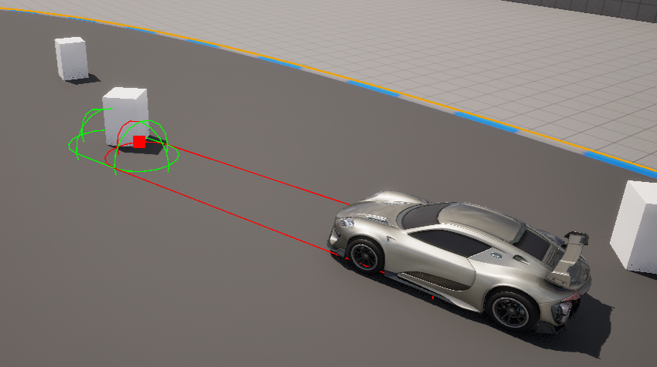

#### Approach 2: Single Sphere Trace With Multiple Obstacle Observation

To enhance the functionality of the existing obstacle avoidance, not one but all obstacles are observed. The sphere cast radius is increased to 4m, encapsulating much more area than the previous approach. The vision still consists of a singular “eye”, but much bigger. A penalty of -10 is given if the agent collides with an obstacle (See Appendix E: Obstacle Avoidance – Approach 2 for Blueprint implementation).

Figure 13: Agent with a singular sphere cast and enhanced radius

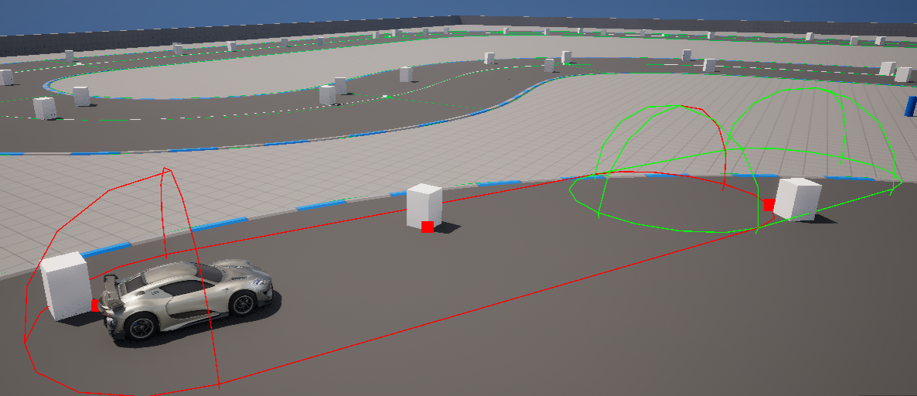

After two hours of training, the observable behavior is slightly improved. This is because the agent’s vision is much larger than previously. It is important to note that the behavior is still unreliable. This is mainly because of the design of the penalty. Negatively rewarding the agent once the collision has already occurred is simply not a good choice. The agent does not learn to anticipate the collision, but rather waits until the collision has already happened. This does not lead to desired behavior. The agent consistently hits the obstacles.

A major conclusion to draw from the experiments so far is that the agent must observe the surroundings as much as possible, and it should anticipate the collision and be punished, before the collision occurs.

#### Approach 3: Multiple Line Traces

To account for the shortcomings of the previous approaches, the agent’s vision is extended. Five line traces are cast, each with a relative angle to the forward vector. The angles are -10°, -5°, 0°, 5° and 10°. The distance of the vision is still 10m. Obstacles detected by the agent’s vision are saved in an array. A new observation of type *bool*is made. The agent observes if this array of detected obstacles is empty or not. This information is used to give a penalty of -10 if this array is not empty, meaning that the agent gets a penalty every time it detects an obstacle (see Appendix F: Obstacle Avoidance – Approach 3 for Blueprint implementation). This approach is pursued out of curiosity, to observe how the agent will behave when detecting an obstacle is considered a bad action. The assumption is that the agent will learn to “look away” from any obstacle once it has detected, leading to naturally avoiding the obstacle.

Figure 14: Agent with 5 lines representing the vision

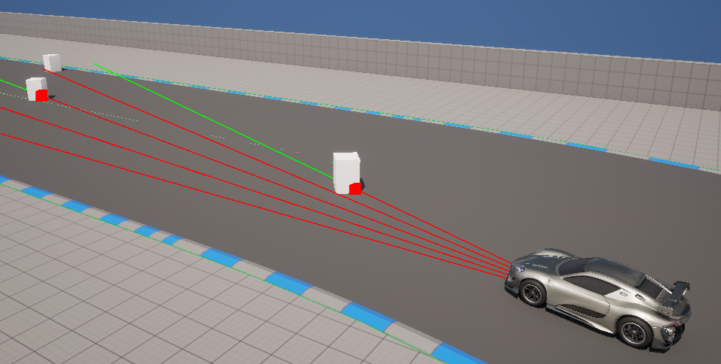

After two hours of training, there is a notable change in the agent’s behavior. As anticipated, the agent tries to look away, causing it to navigate past the obstacles. The downside is that if an obstacle is too close to the side of the road, the agent drives off the road in order to avoid collision. While this is a significant improvement, it still requires refining.

There are two places to look for improvements: interactor and trainer. An upgrade to the interactor would mean adding additional lines to represent the vision, while an upgrade to the trainer would indicate either experimenting with different reward values or designing a new reward system. To detect where the error lies, the interactor will stay untouched. A new reward will be introduced, replacing the existing negative reward for collision.

When the agent gets closer than 40m to the closest obstacle detected, it is given a reward of -10.

Figure 15: Penalty for getting too close to an obstacle

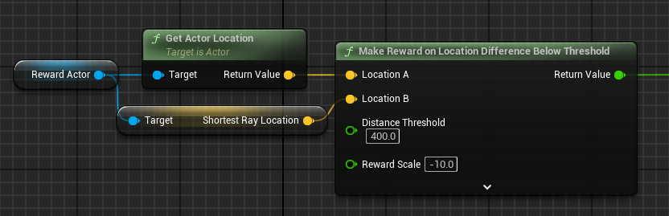

This change demonstrates the importance of a good reward system design. After the following change, the behavior is notably improved. The agent tries to stay within bounds while avoiding obstacles. There are still situations where the agent collides with obstacles. Approach 4 solves the above issues, introducing the first working version of the agent, ready for training with multiple batch sizes.

#### Approach 4: Smart Agent

The first change contributing to the desired outcome concerns the observations. To make sure that the agent does not miss any obstacles ahead, two more rays are added to the vision, making it a total of seven rays between -45° and 45°. The range of the vision is also greatly enhanced. Now, the agent can see 100m ahead.

The reward system is also adjusted. If the agent gets closer than 50m to an obstacle within -11.7° and 11.7° relative to its forward vector, a significantly greater negative reward of -25 is given. To further enhance the reward system, upon collision, a negative reward of -50 is given (see Appendix G: Obstacle Avoidance – Approach 4 for Blueprint implementation).

The above-mentioned changes result in a smart agent, avoiding obstacles after two hours of training. It is important to note that the chosen rewards were determined through an iterative process of experimentation, where the values that yielded satisfactory results were selected for further use. These values are not necessarily the best or most optimal, however, for the purposes of this paper, a sufficiently effective configuration is deemed adequate to achieve the desired outcomes. For this reason, the agent’s configuration will not change from this point on, and training iterations for each batch size, as provided before, will be conducted.

Figure 16: Multiple agents driving around the track

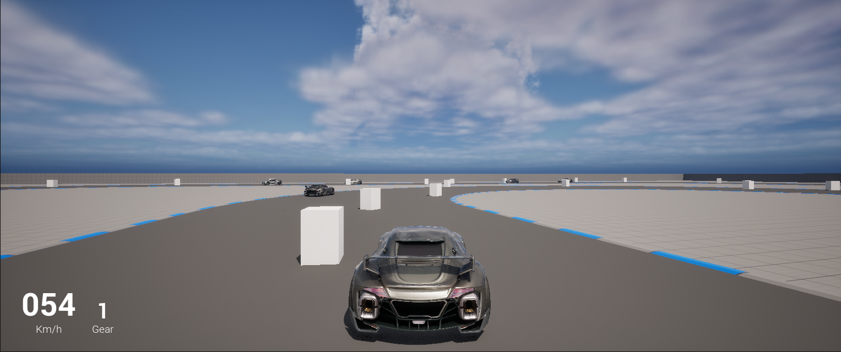

### Analyzing Training Data

## Testing

Mention testing details here

### Environment

### Data Collection

## Results

# Discussion

**In this section, you offer an interpretation of the results you obtained and try to relate them to the theoretical framework you presented. This is typically not a very long section, but obviously one of the most important ones.**

Lorem ipsum dolor sit amet, consectetur adipiscing elit. Vestibulum ac quam nec arcu semper dignissim. Nulla quam magna, varius sit amet pharetra et, dictum quis elit. Pellentesque habitant morbi tristique senectus et netus et malesuada fames ac turpis egestas.

Proin ullamcorper, ipsum sit amet scelerisque rhoncus, leo quam rhoncus elit, sit amet ullamcorper tellus nisi eget sapien. Suspendisse potenti. Ut non justo viverra, tempus felis vitae, elementum mi. Morbi at dui sed lacus fringilla condimentum. Duis non odio ac arcu volutpat vehicula eu et turpis.

Praesent vitae magna ante. Nulla in orci lacus. Donec quis vestibulum mi. Sed ipsum sapien, pretium maximus purus sed, bibendum consequat lectus. Aliquam porttitor dolor eu gravida vulputate. Vestibulum ut urna eget massa tincidunt ultricies. Morbi hendrerit sapien at diam tincidunt semper. Aliquam ut quam dictum quam maximus tempor sed at felis.

# Conclusion

**In this section, you ascertain the demonstrable outcomes of your study and outline the merits of the project for the academic field and the discourse community. This is typically not a very long section, but obviously also one of the more important ones.**

Lorem ipsum dolor sit amet, consectetur adipiscing elit. Vestibulum ac quam nec arcu semper dignissim. Nulla quam magna, varius sit amet pharetra et, dictum quis elit. Pellentesque habitant morbi tristique senectus et netus et malesuada fames ac turpis egestas.

Proin ullamcorper, ipsum sit amet scelerisque rhoncus, leo quam rhoncus elit, sit amet ullamcorper tellus nisi eget sapien. Suspendisse potenti. Ut non justo viverra, tempus felis vitae, elementum mi. Morbi at dui sed lacus fringilla condimentum. Duis non odio ac arcu volutpat vehicula eu et turpis.

Praesent vitae magna ante. Nulla in orci lacus. Donec quis vestibulum mi. Sed ipsum sapien, pretium maximus purus sed, bibendum consequat lectus. Aliquam porttitor dolor eu gravida vulputate. Vestibulum ut urna eget massa tincidunt ultricies. Morbi hendrerit sapien at diam tincidunt semper. Aliquam ut quam dictum quam maximus tempor sed at felis.

# Future work

This paper explored one approach to developing autonomous driving using Reinforcement Learning. In machine learning, parameter tuning plays a critical role, so future work could focus on optimizing the balance between rewards and penalties to further enhance obstacle avoidance. Another potential direction could involve integrating dynamic obstacle avoidance and analysing how batch size influences performance in such scenarios.

Additionally, expanding the scope of observations and actions, by for example incorporating traffic conditions, could provide valuable insights into more complex driving behaviours. As the Learning Agents plugin continues to evolve, new features and possibilities are likely to emerge, opening further avenues for exploration and innovation in autonomous driving research.

# Critical Reflection

I began this research with no prior knowledge of Machine Learning. Through extensive reading and practical experimentation, I have developed a strong understanding of Reinforcement Learning, particularly how it can be applied to train agents for use in games. While my experiments focused specifically on autonomous driving, I’ve realized that the principles of Reinforcement Learning, namely defining observations, actions, and rewards, are broadly applicable across different domains.

This research has inspired me to explore Learning Agents further, experimenting with their capabilities beyond the scope of this project. Given that the Learning Agents plugin is still in an experimental stage, I plan to closely follow its development and adapt to its evolving features.

Looking ahead, I am excited about the potential for Reinforcement Learning to become more integrated into everyday applications. This research has been both challenging and rewarding, providing me with valuable insights and a strong foundation to build upon in future projects.

# References

**In this section, you list all the references you made in alphabetical order; consequently adhere to the referencing style you have chosen.**

Casey Raes (2014), Processing (second edition).

Saccade. (n.d.). In Wikpedia. Retrieved November 6 2016 from <https://en.wikipedia.org/wiki/Saccade>

Sarah Northway (2016) A year in VR Northway [Powerpoint slides] from <https://www.gdcvault.com/play/1024631/A-Year-in-VR-A>

# Acknowledgements

I would like to thank Alexandros Kougentakos for his invaluable assistance in troubleshooting my obstacle avoidance system. I am also deeply grateful to Kasper Geeroms, my coach, for his support and to Fries Boury, my supervisor, for his continuous guidance throughout this project.

# Appendices

## Appendix List

* Appendix A: Learning Agents Framework
* Appendix B: Learning To Drive
* Appendix C: Obstacle Avoidance – Setup
* Appendix D: Obstacle Avoidance – Approach 1
* Appendix E: Obstacle Avoidance – Approach 2
* Appendix F: Obstacle Avoidance – Approach 3
* Appendix G: Obstacle Avoidance – Approach 4

## Appendix A: Learning Agents Framework

Figure A1: SpecifyAgentObservation function in Learning Agents 5.4

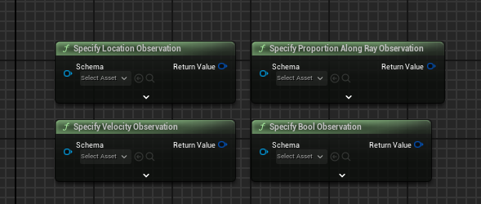

Figure A2: GatherAgentObservation function in Learning Agents 5.4

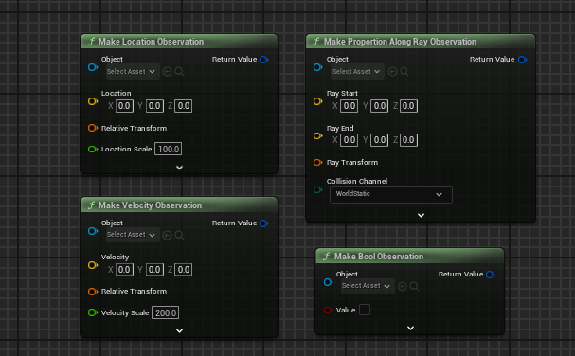

Figure A3: SpecifyAgentAction and PerformAgentAction in Learning Agents 5.4

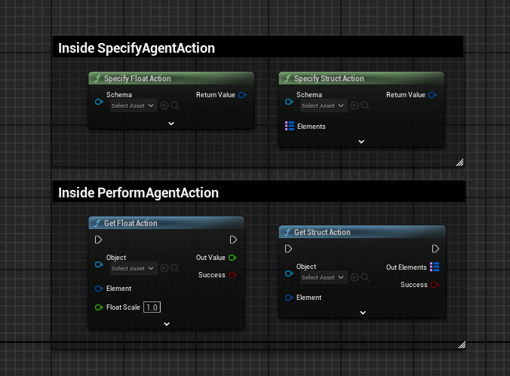

Figure A4: GatherAgentReward in Learning Agents 5.4

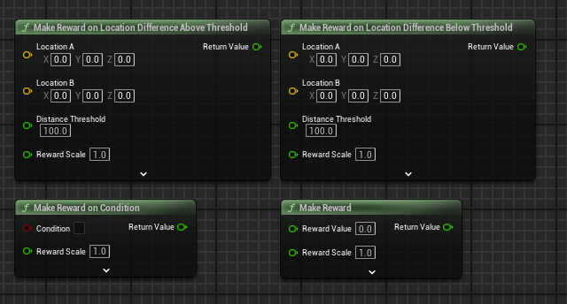

Figure A 5: GatherAgentCompletion in Learning Agents 5.4

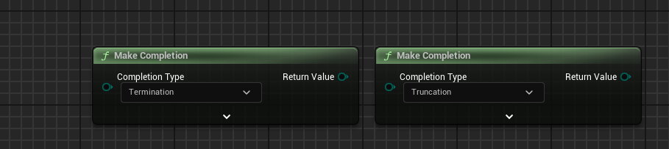

## Appendix B: Learning To Drive

Figure B1: Velocity observation in Blueprints

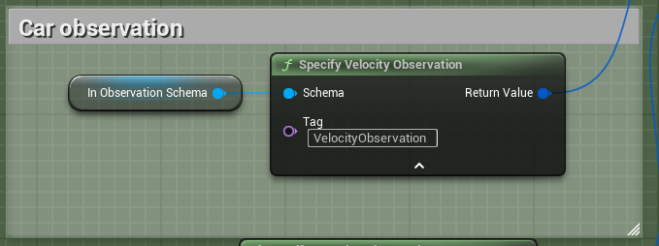

Figure B2: Mapping the observations together

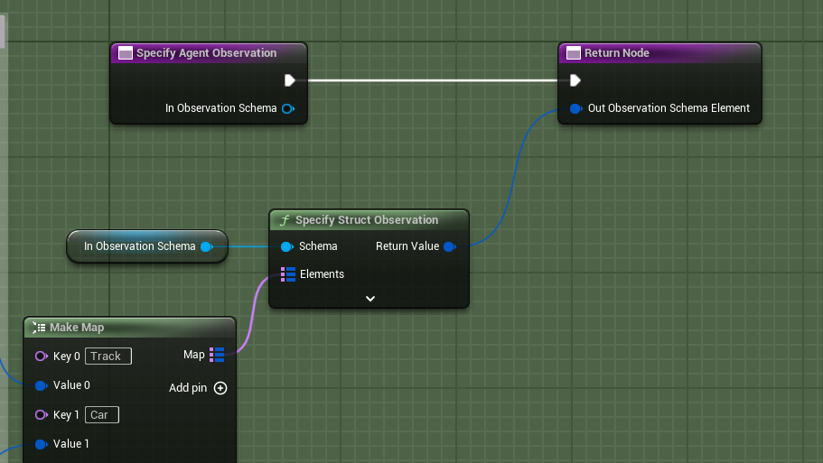

Figure B3: Track Distance Samples Array

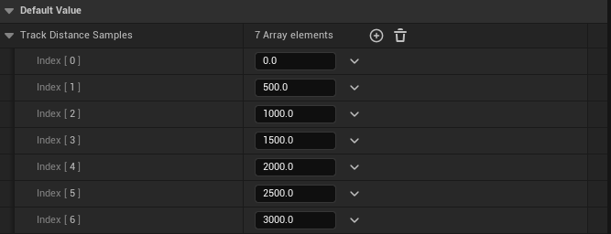

Figure B4: Finding Sample Distance Per Sample

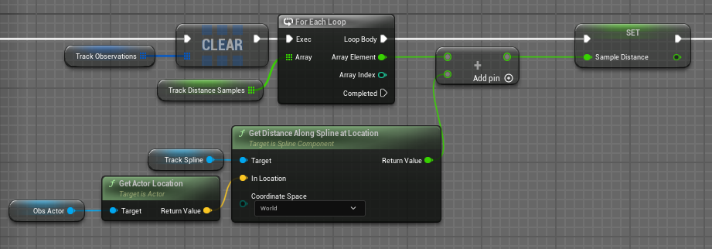

Figure B5: Gathering Location & Direction Along Spline Observations

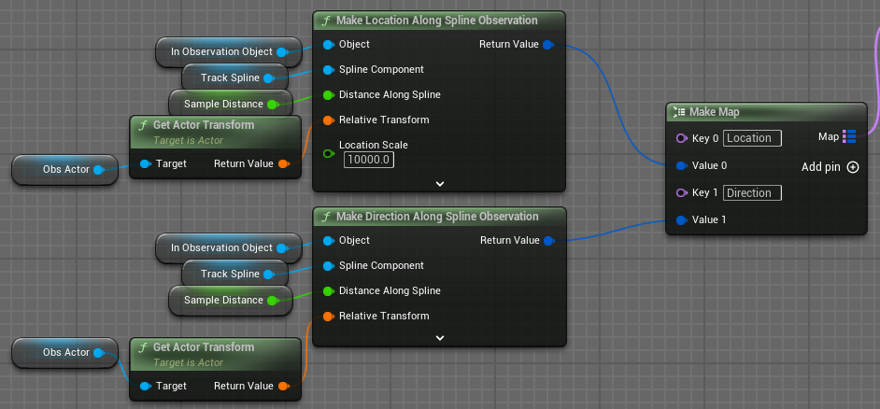

Figure B6: Saving Location & Direction Along Spline Observations into an array

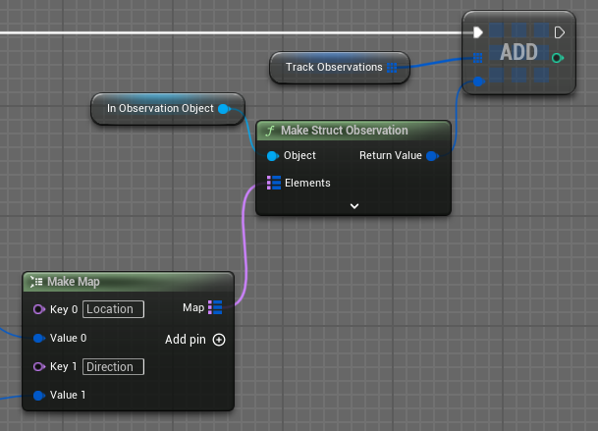

Figure B7: GatherAgentObservation function output

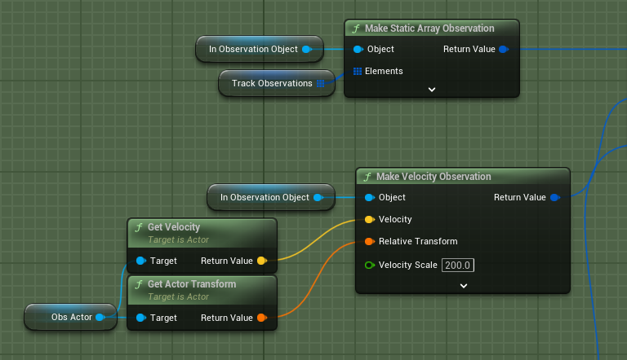

Figure B8: SpecifyAgentAction full implementation

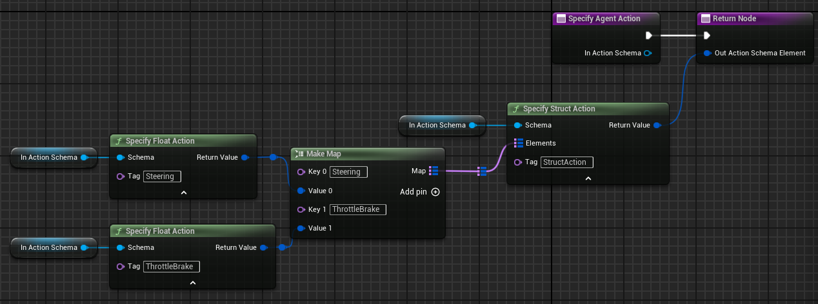

Figure B9: Throttle/brake action if the float action value is greater than 0

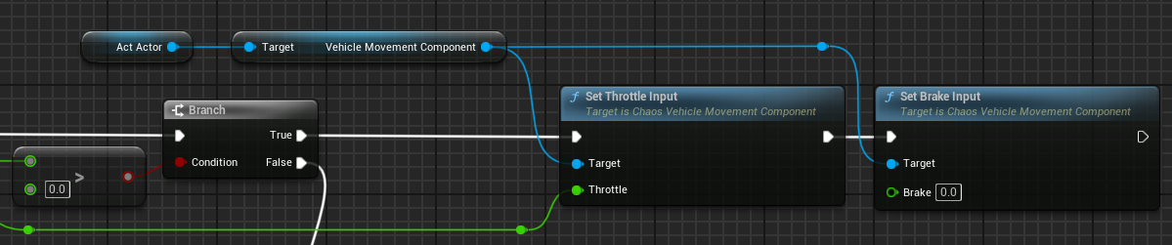

Figure B10: Throttle/brake action if the float action value is less than 0

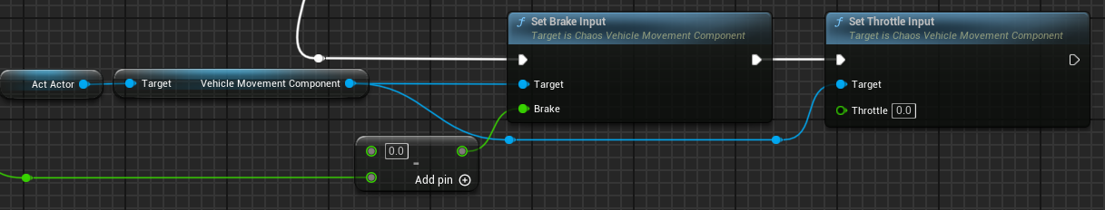

Figure B11: Accessing float action for Steering

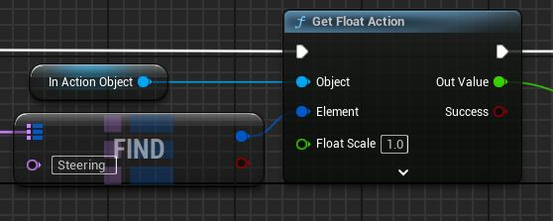

Figure B12: Accessing float action for Throttle/brake

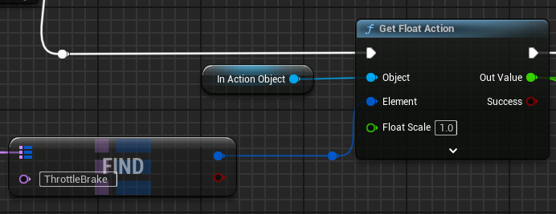

Figure B13: Penalty for leaving the road

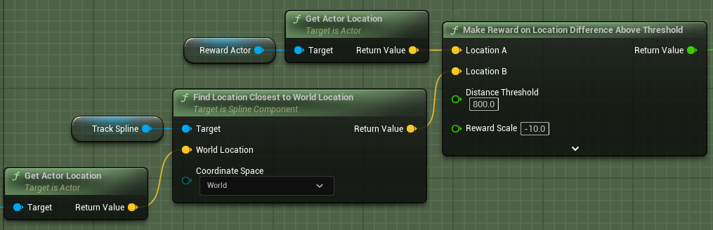

Figure B 14: Reward for driving as fast as possible along the spline

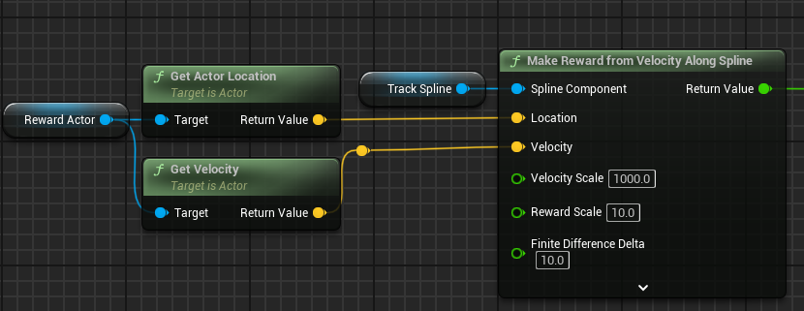

Figure B 15: Termination if the agent drives outside of the bounds

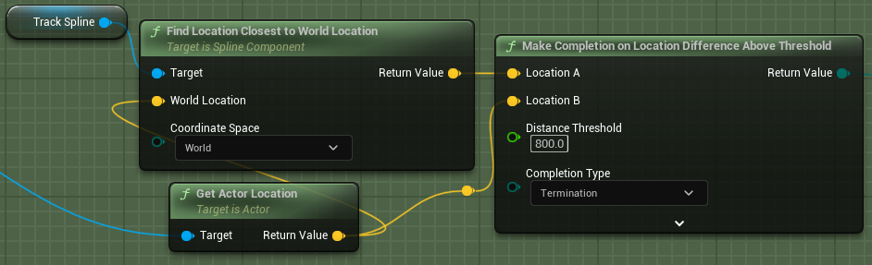

## Appendix C: Obstacle Avoidance – Setup

Figure C1: Static obstacle used in this research

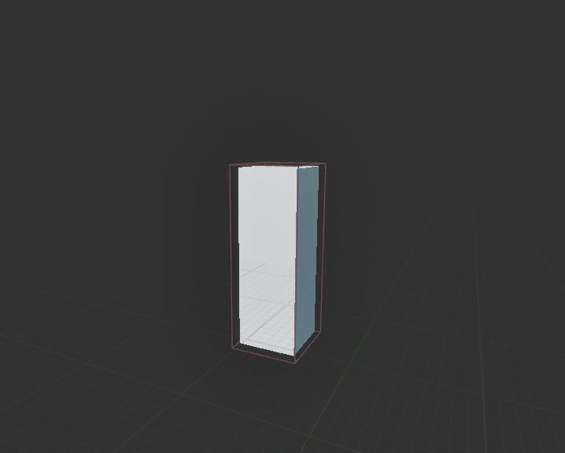

Figure C2: Randomizing the location of the obstacle

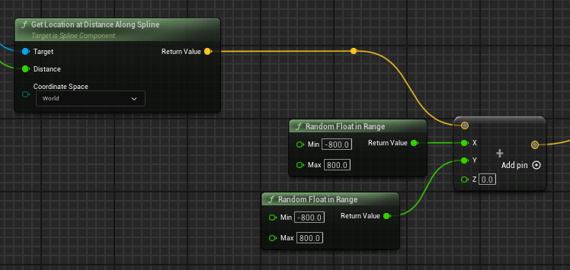

Figure C3: Spawning the obstacle

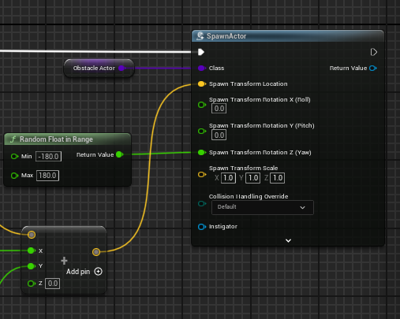

## Appendix D: Obstacle Avoidance – Approach 1

Figure D1: Calculating end of line segment for sphere tracing

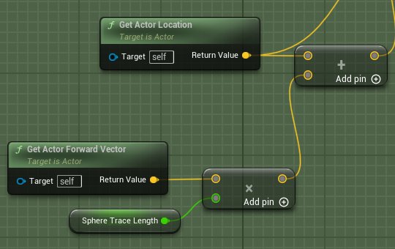

Figure D2: Sphere tracing for obstacles

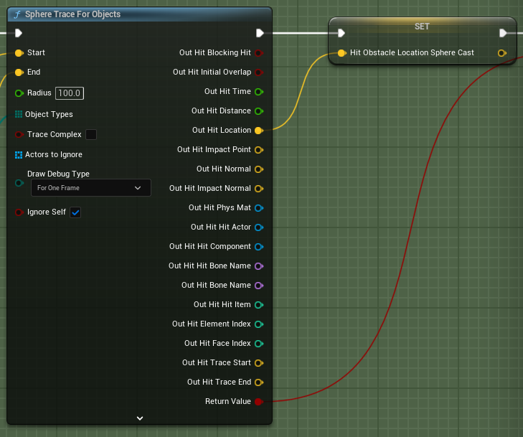

Figure D3: Gathering obstacle observation

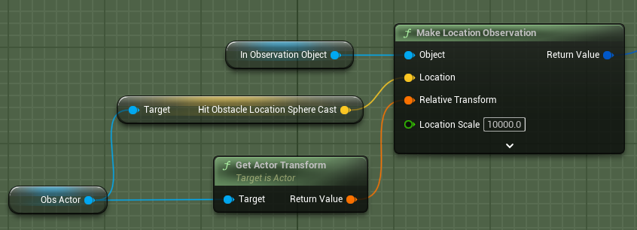

Figure D4: Specifying obstacle observation

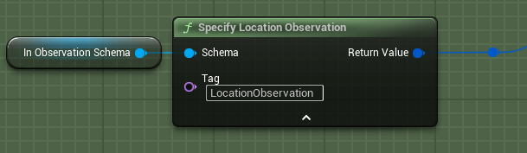

Figure D5: Calculating agent to obstacle vector

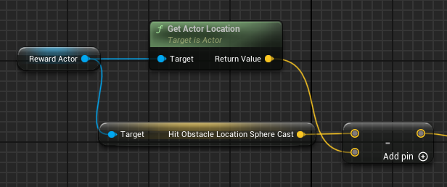

Figure D6: Agent penalty for facing an obstacle

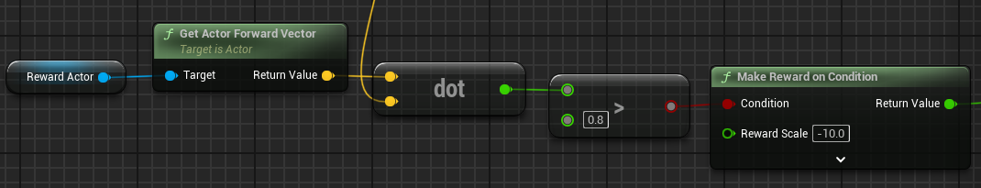

## Appendix E: Obstacle Avoidance – Approach 2

Figure E1: Multi sphere tracing for obstacles

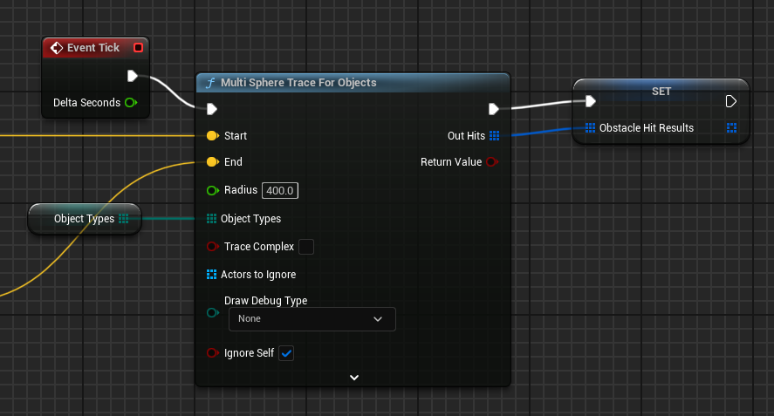

Figure E2: Specifying obstacle observation

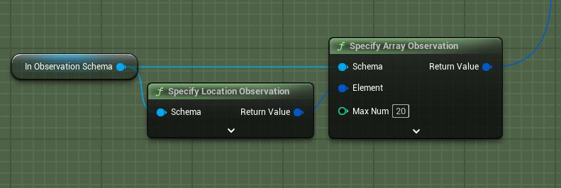

Figure E3: Gathering obstacle observation

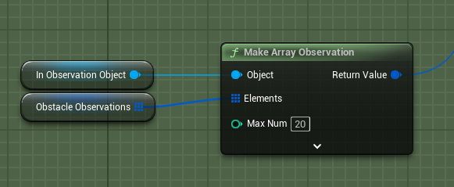

Figure E4: Agent penalty for colliding with an obstacle

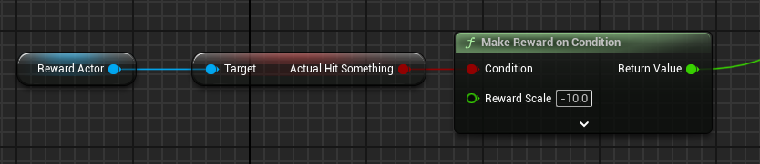

## Appendix F: Obstacle Avoidance – Approach 3

Figure F1: Starting angles of agent's "vision"

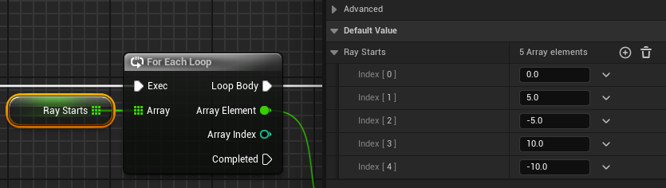

Figure F2: Rotating the forward vector to calculate "vision" vectors

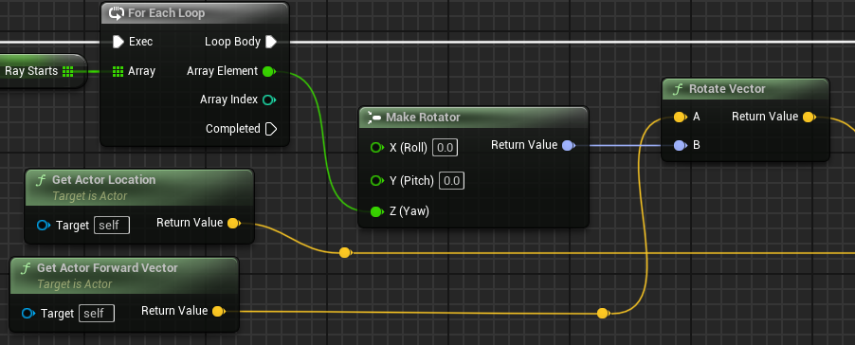

Figure F3: Simulating the "vision" using line trace

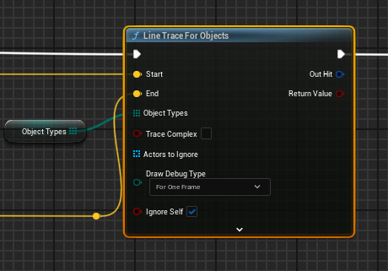

Figure F4: Specifying "vision" ray observation

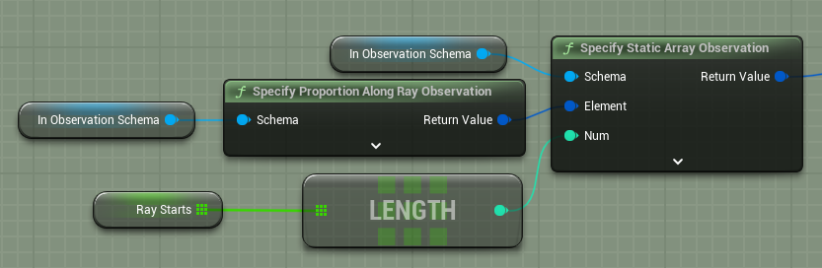

Figure F5: Specifying collision bool observation

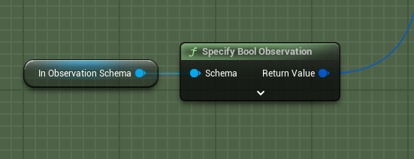

Figure F6: Gathering "vision" ray observation

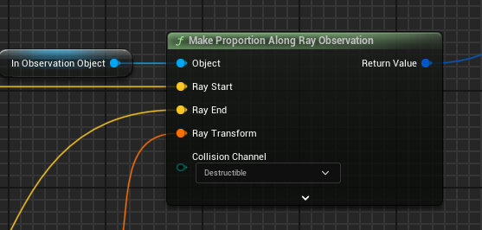

Figure F7: Gathering collision bool observation

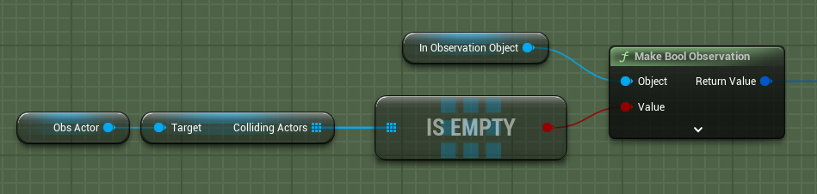

Figure F8: Negatively rewarding the agent for detecting obstacles

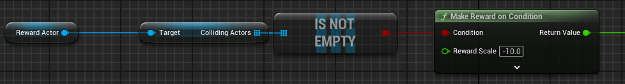

## Appendix G: Obstacle Avoidance – Approach 4

Figure G1: Calculating lines for vision at different angles

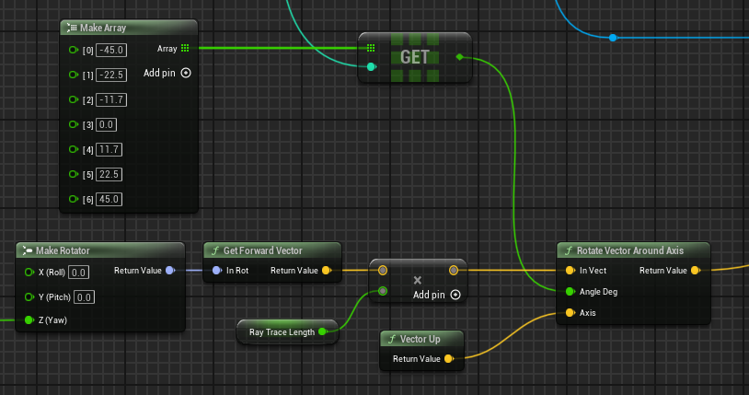

Figure G 2: Making ray observations, simulating the agent's vision

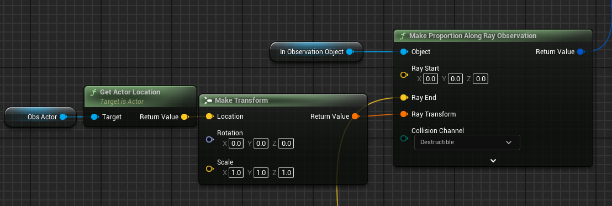

Figure G3: Observing too close obstacles that should cause a negative reward

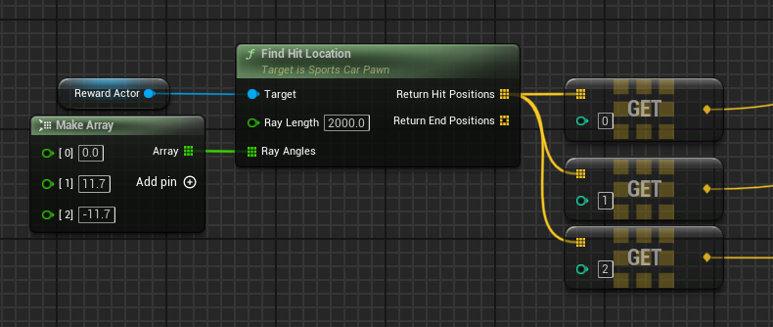

Figure G 4: Negative reward if the agent gets too close to an obstacle

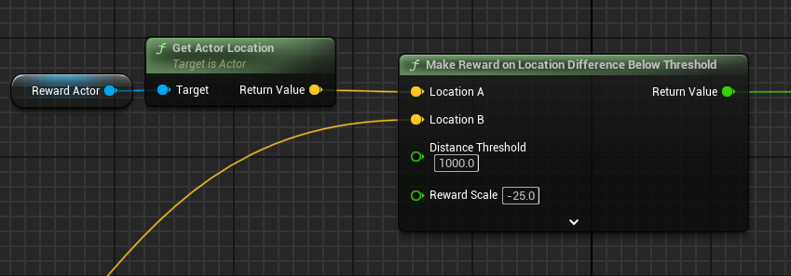

Figure G5: Negative reward for colliding with an obstacle

